Wireshark Final Exam

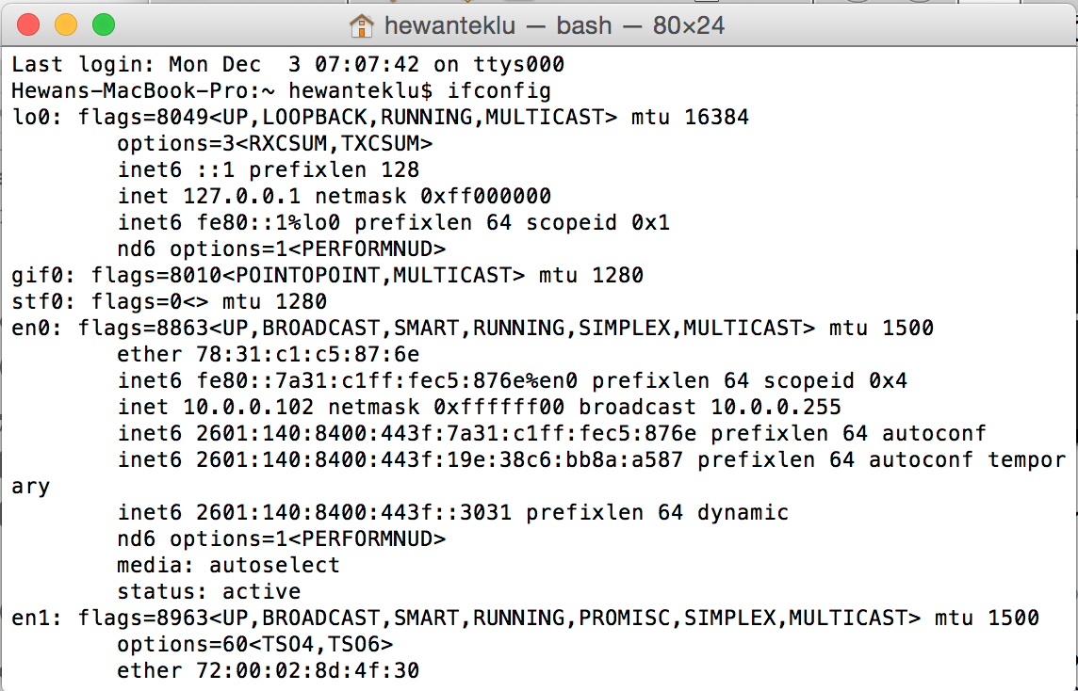

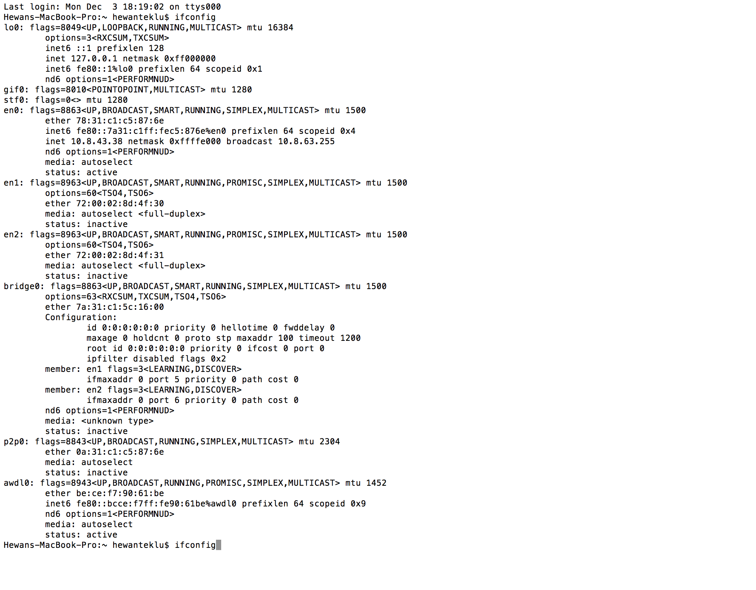

Visit: <http://gaia.cs.umass.edu/wireshark-labs/HTTP-wireshark-file3.html>

1. How many HTTP GET request messages did your browser send? Which packet number in the trace contains the GET message for the Bill of rights?

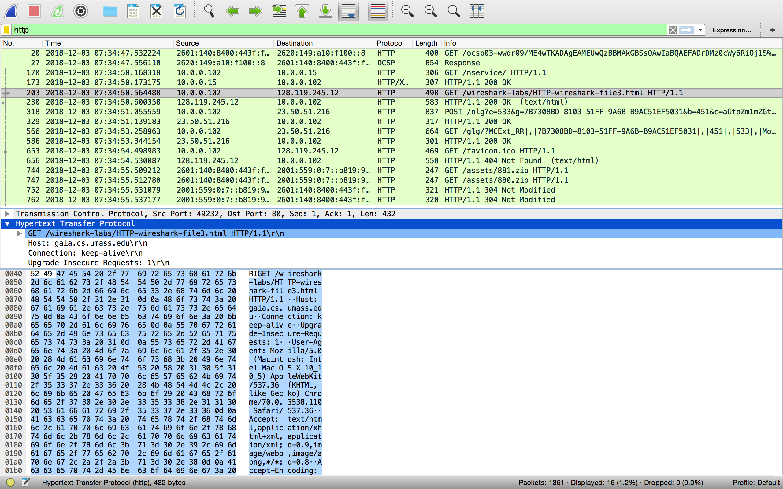

**Solution:**

My browser sent seven (7) GET messages. Packet 203 contains the GET message for the Bill of rights.

1. Which packet number in the trace contains the status code and phrase associated with the response to the HTTP GET request?

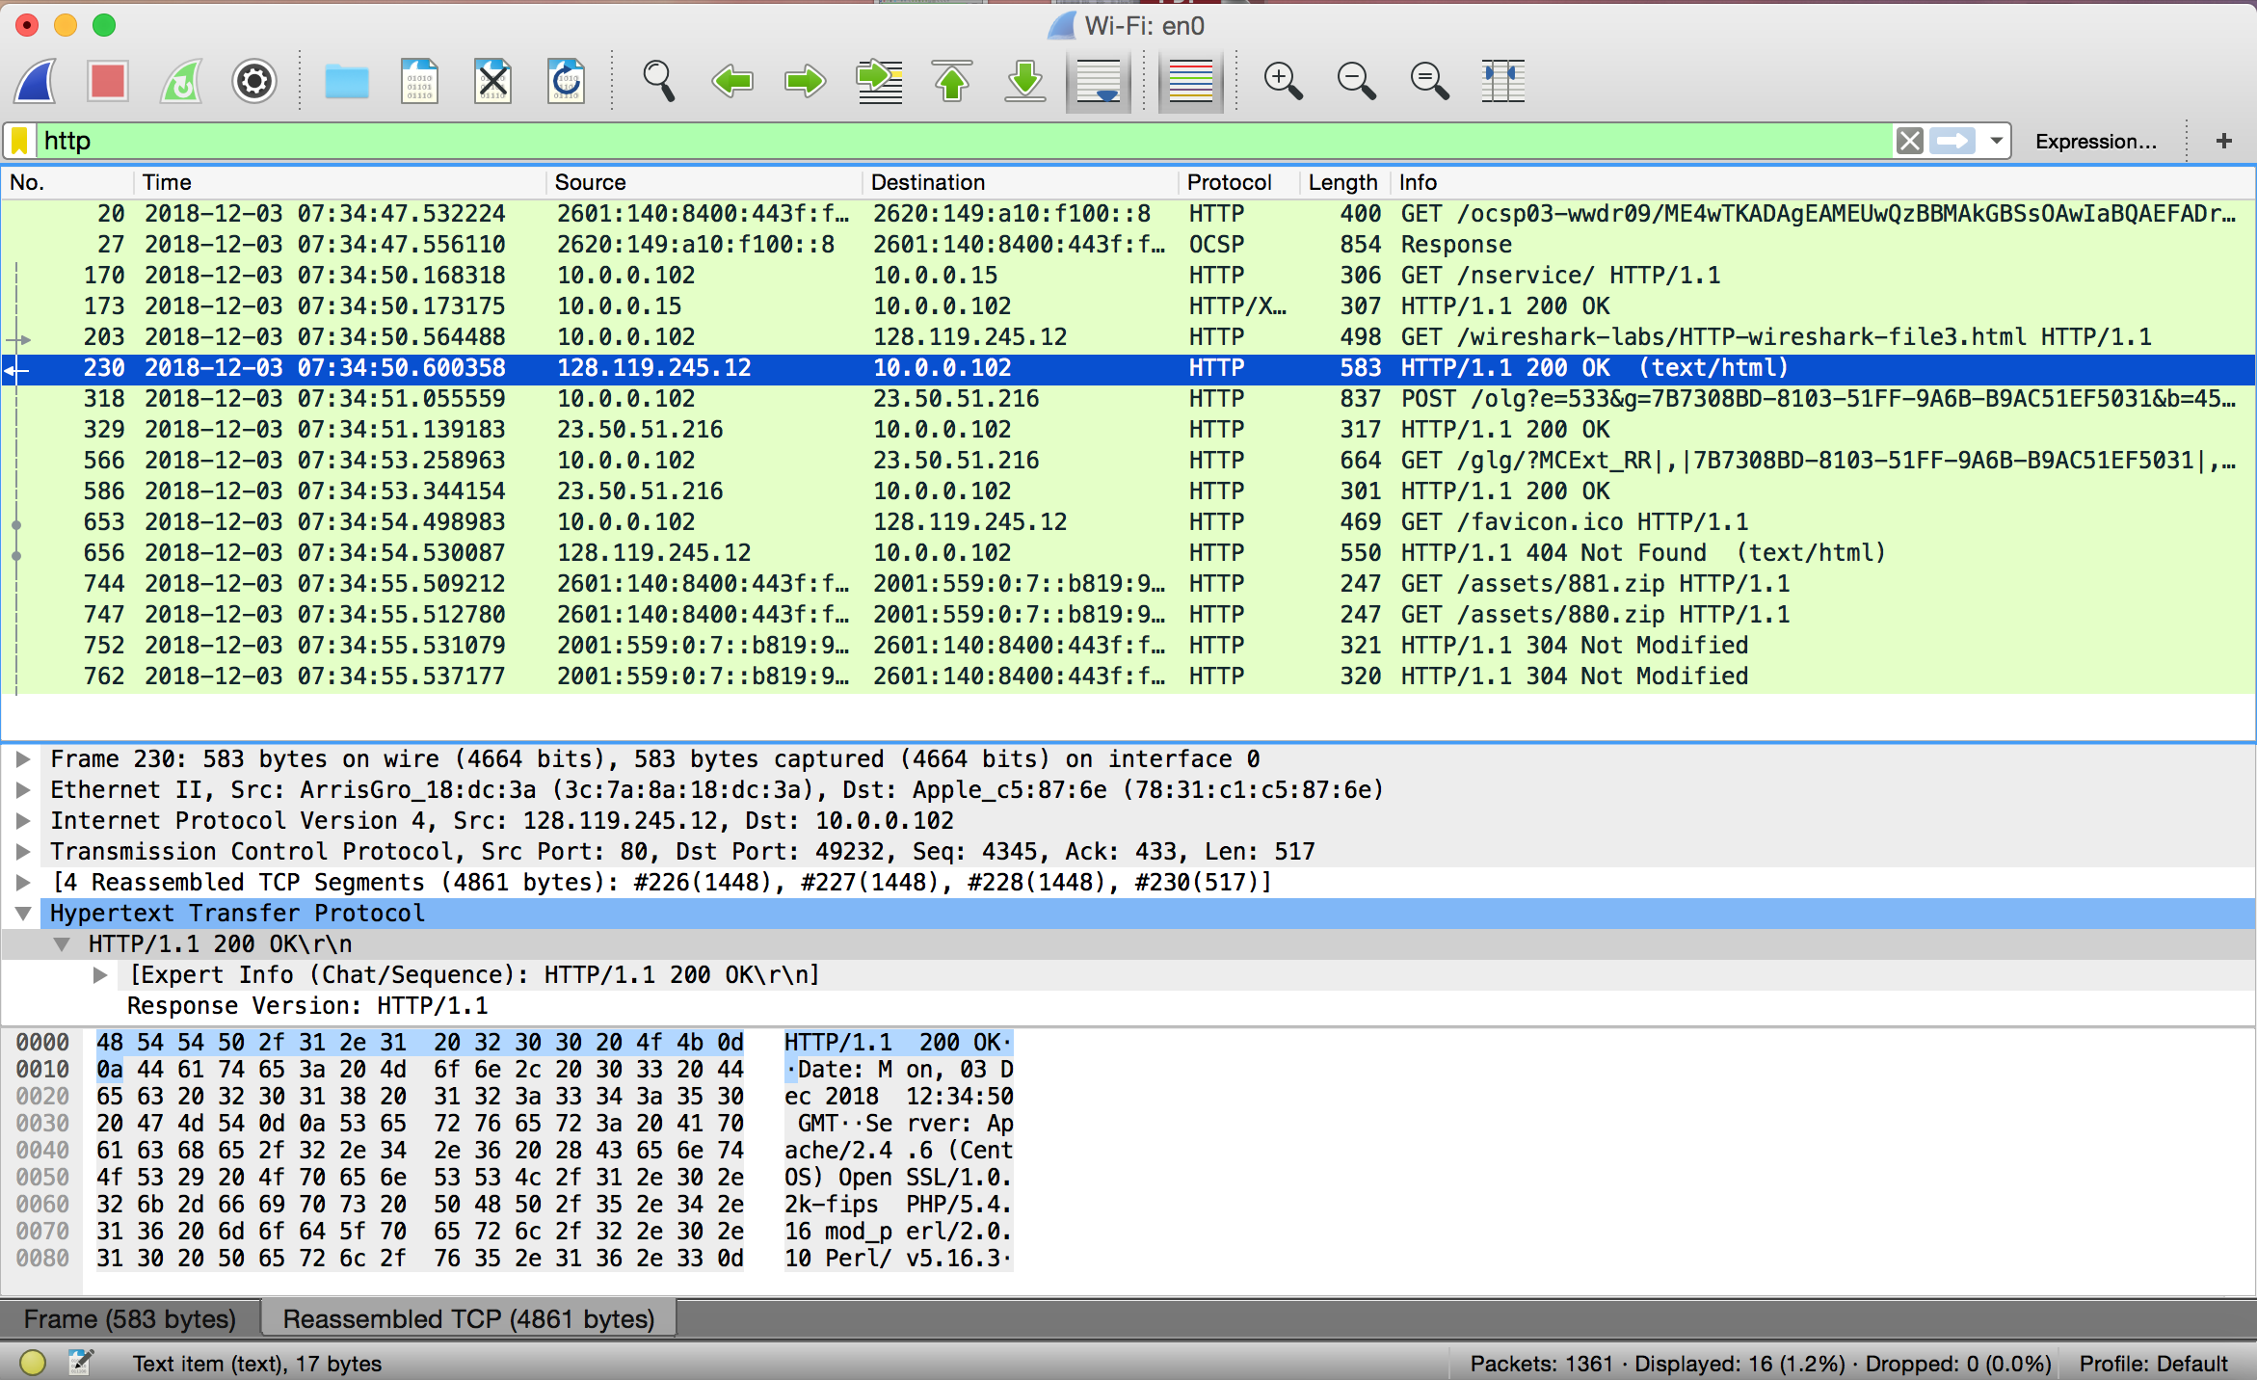

**Solution:**

230

1. What is the status code and phrase in the response?



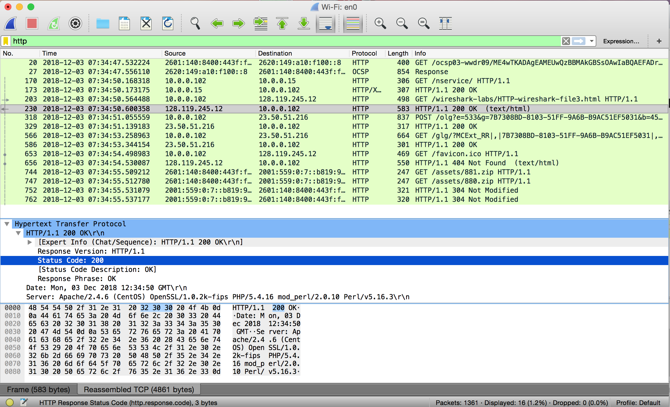

**Solution:**

Code 200 OK

1. How many data-containing TCP segments were needed to carry the single HTTP response and the text of the Bill of rights?

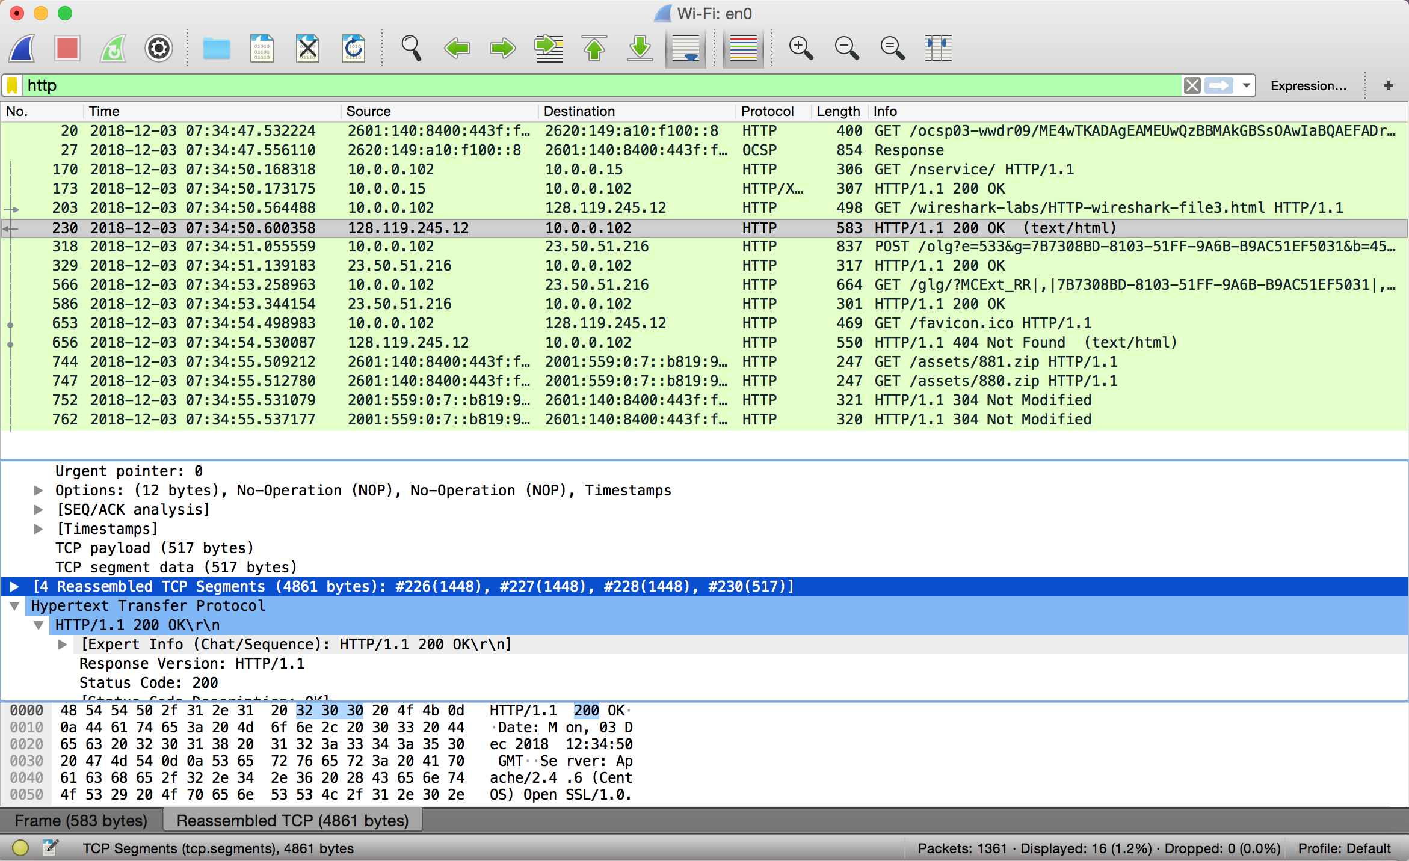

**Solution:**

Four (4) TCP Segements.

Visit: <http://gaia.cs.umass.edu/wireshark-labs/protected_pages/HTTP-wireshark-file5.html>

The username is “wireshark-students” (without the quotes), and the password is “network” (again, without the quotes).

1. What is the server’s response (status code and phrase) in response to the initial HTTP GET message from your browser?

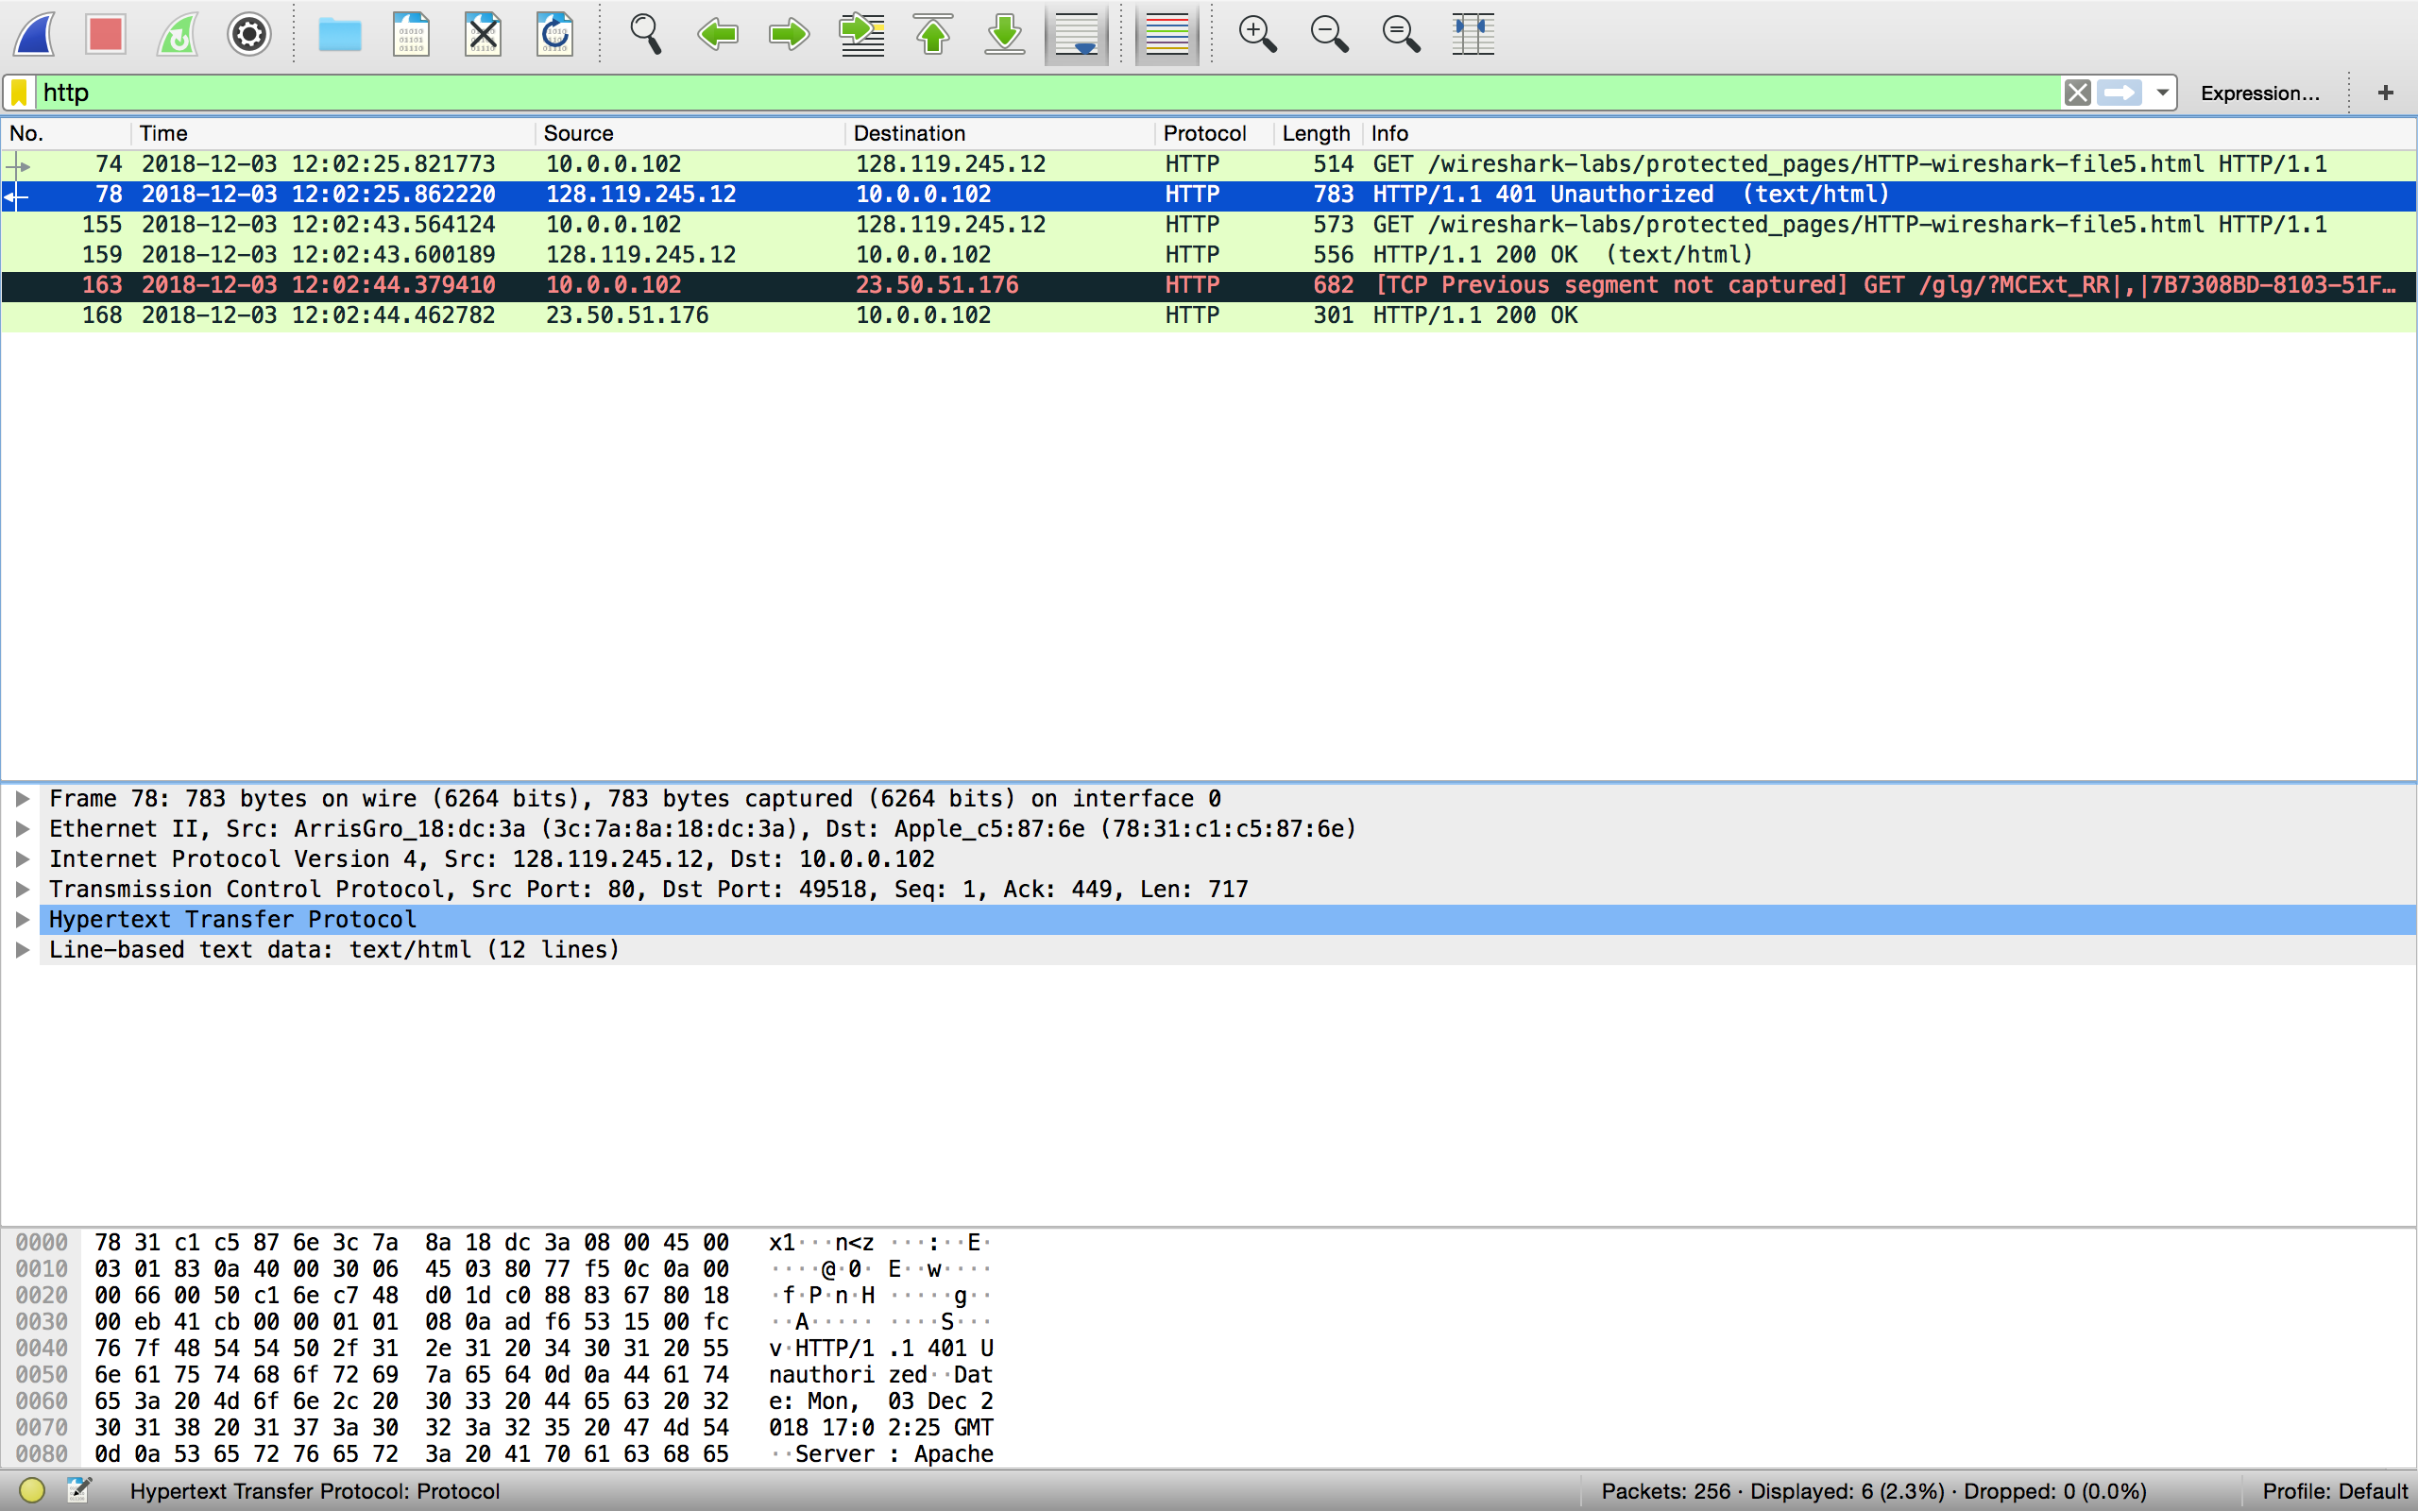

**Solution:**

The Status code is 401 and the phrase is unauthorized.

1. When your browser sends the HTTP GET message for the second time, what new field is included in the HTTP GET message?

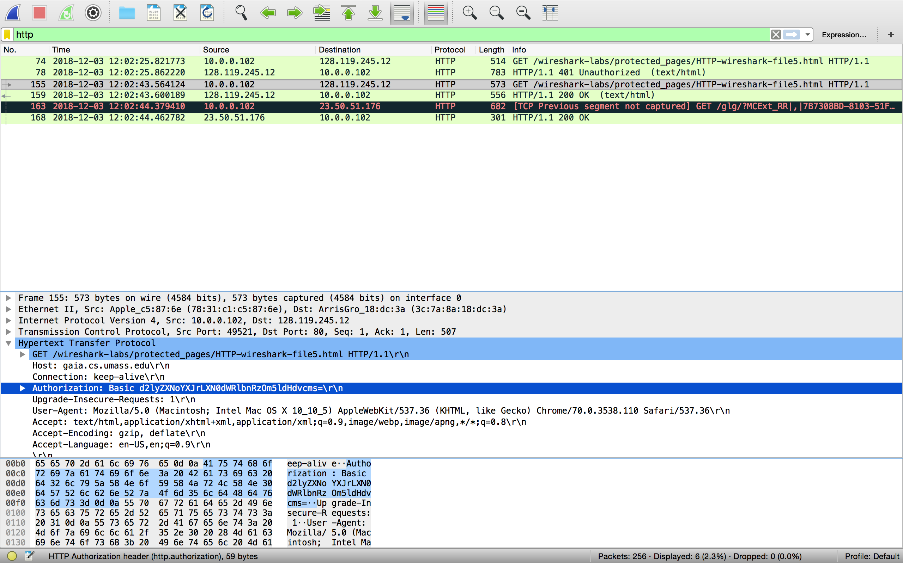

**Solution:**

Authorization-Basic

Visit: [http://www.ietf.org](http://www.ietf.org/) (Hint: Filter Wireshark using “ip addr == your IP”)

1. Locate the DNS query and response messages. Are they sent over UDP or TCP?

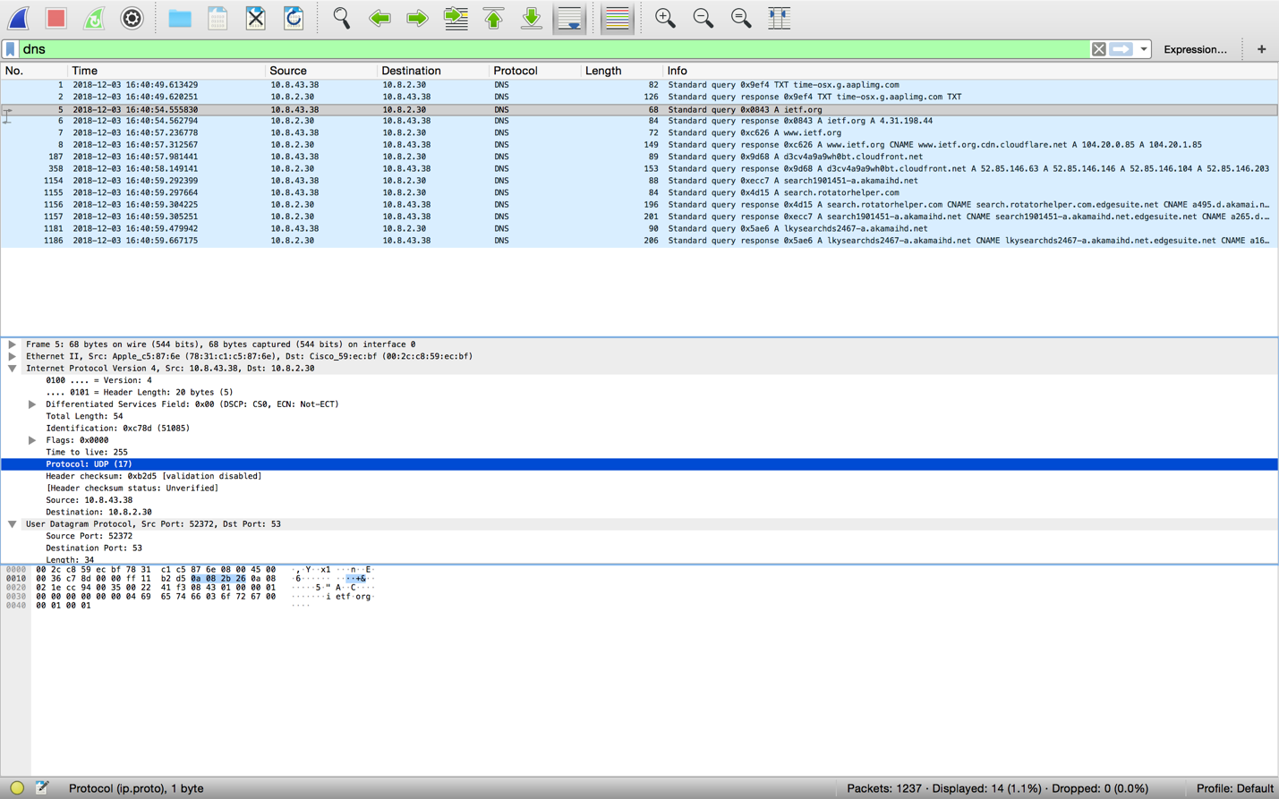

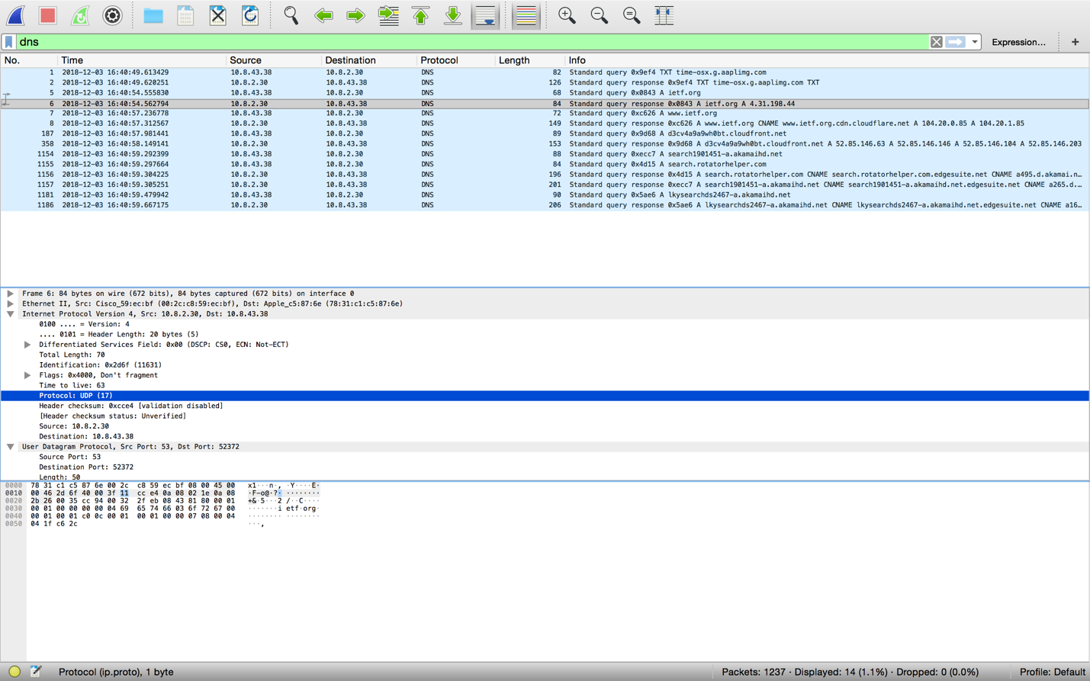

**Solution:**

UDP

1. What is the destination port for the DNS query message?

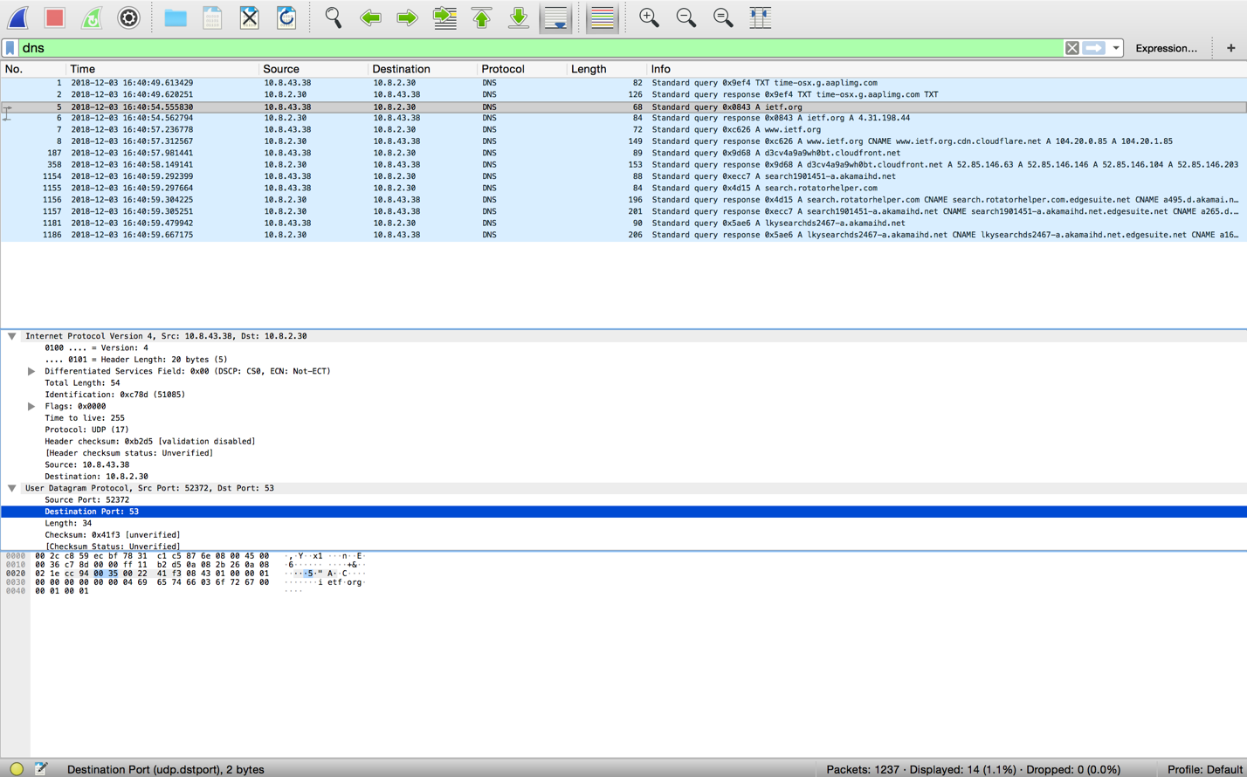

**Solution:**

Destination port: 53

1. What is the source port of DNS response message?

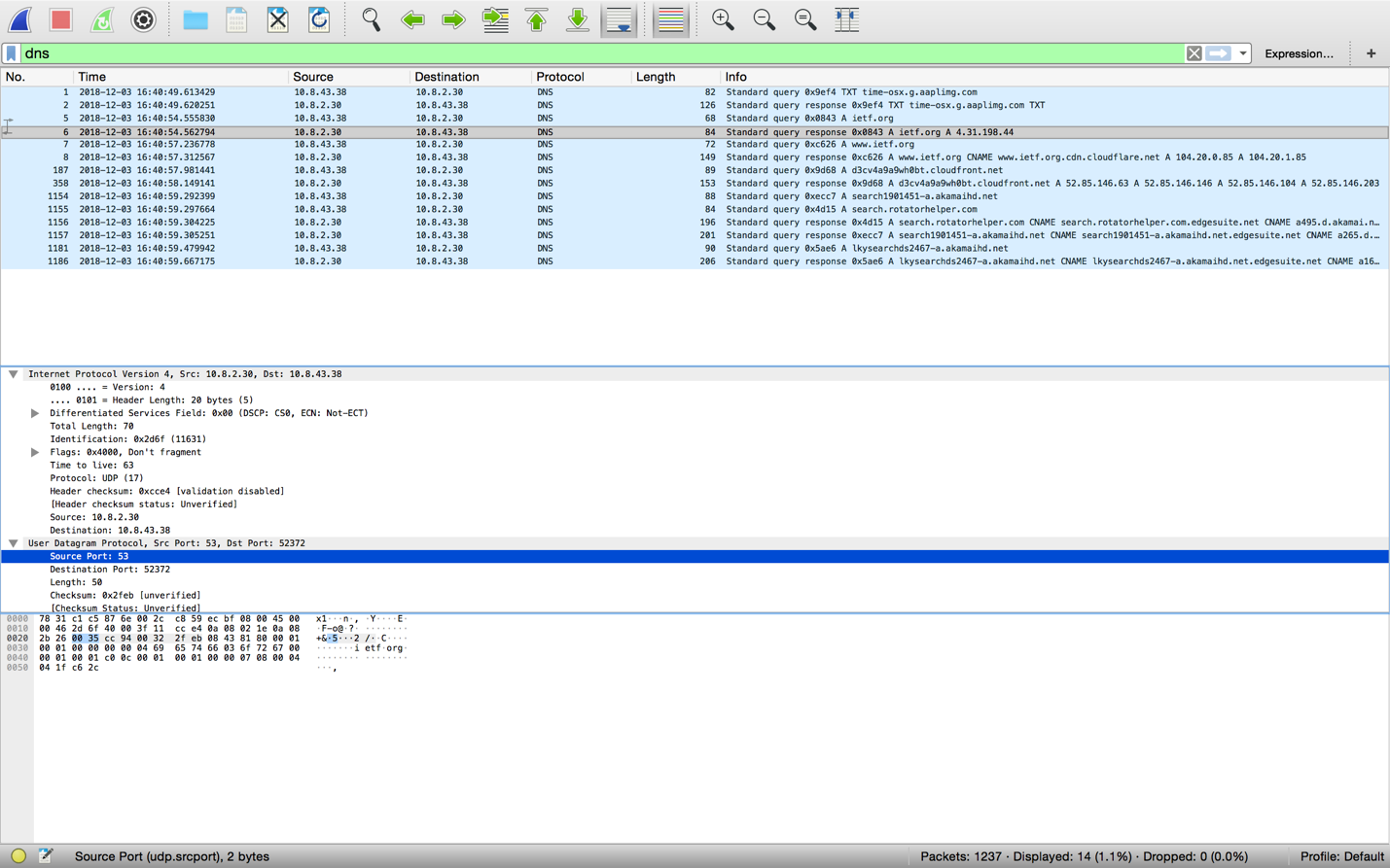

**Solution:**

Source port: 53

1. To what IP address is the DNS query message sent?

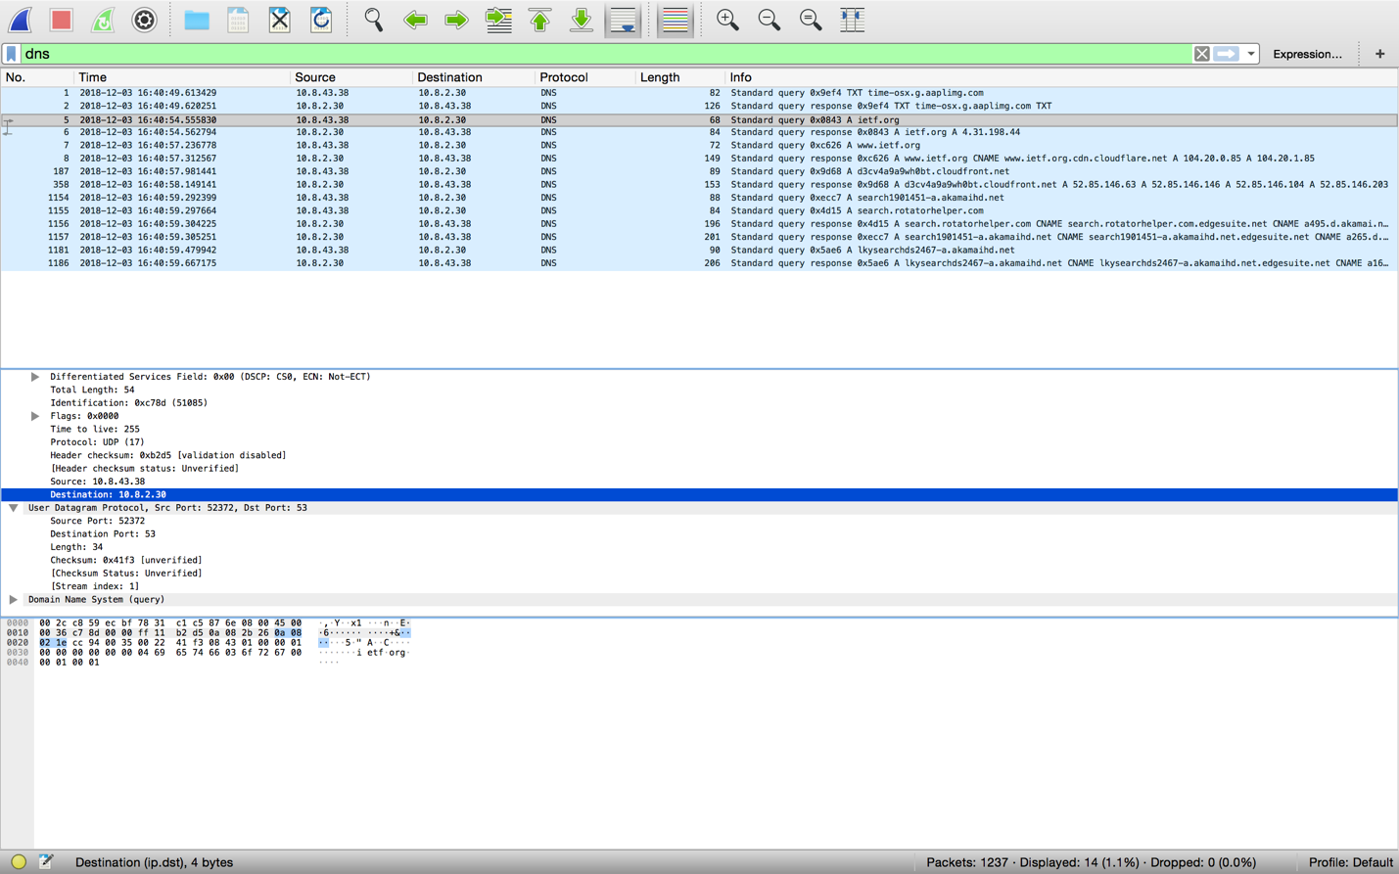

**Solution:**

10.8.2.30

1. Examine the DNS query message. What “Type” of DNS query is it? Does the query message contain any “answers”?

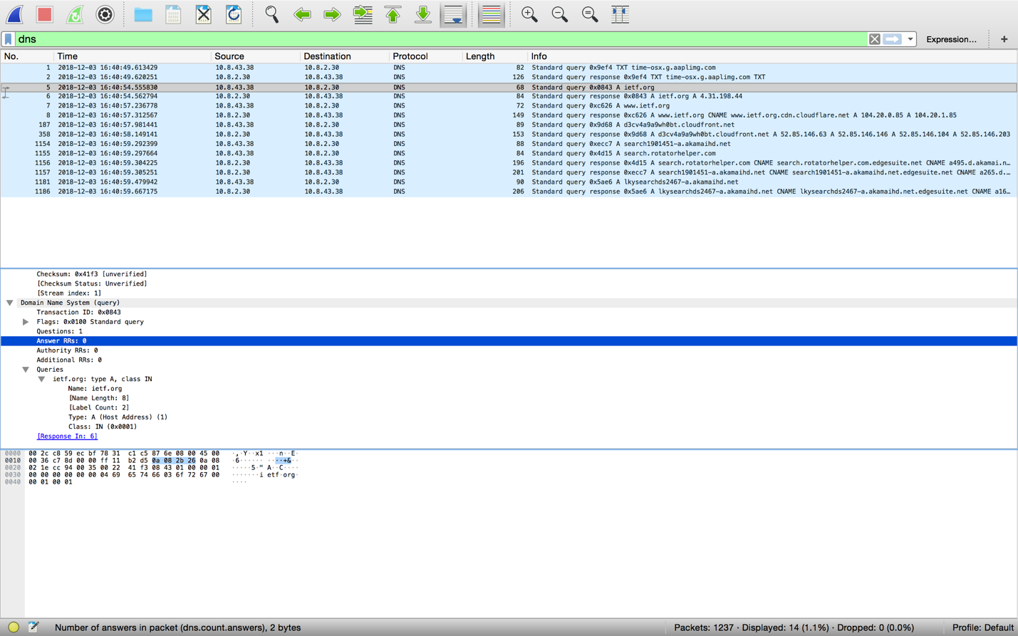

**Solution:**

Standard Query, Type A, No answer

1. Examine the DNS response message. How many “answers” are provided? What do each of these answers contain?

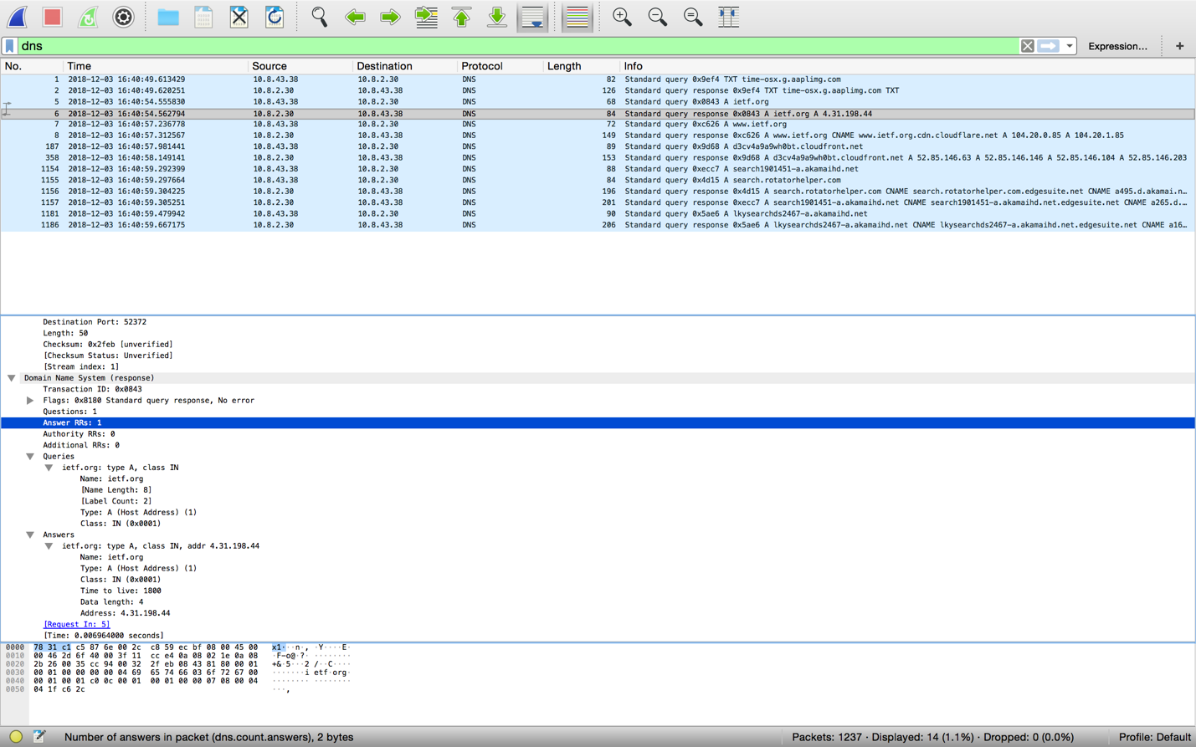

**Solution:**

One answer is provided. It contains name, type, class, time to live, Data length, and Address.

1. Consider the subsequent TCP SYN packet sent by your host. Does the destination IP address of the SYN packet correspond to any of the IP addresses provided in the DNS response message?

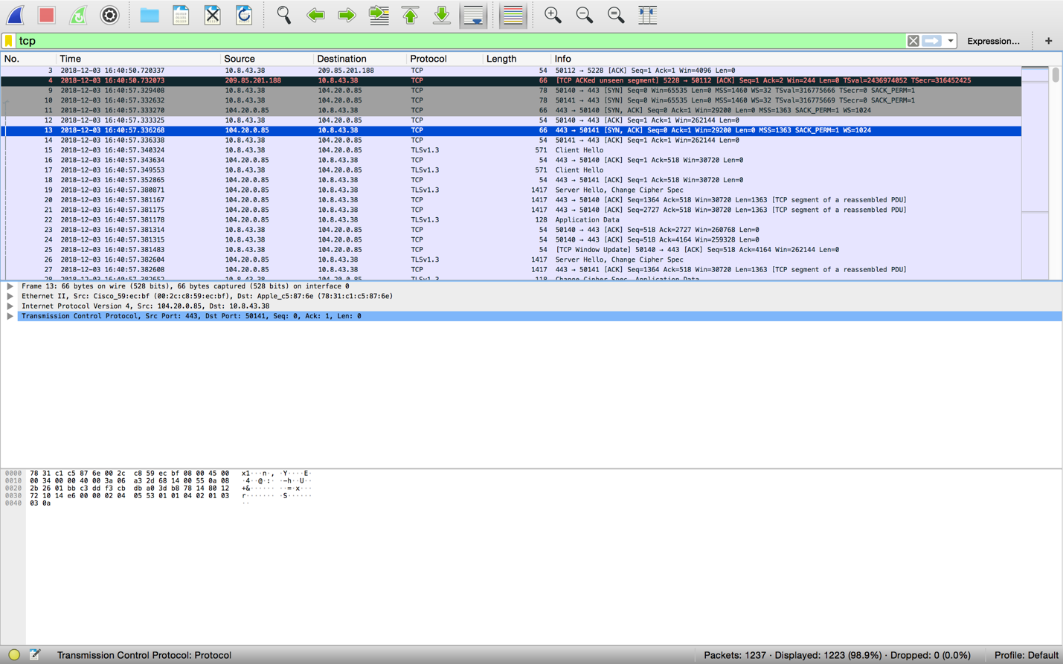

**Solution:**

Yes, 10.8.43.38

Do something that will cause your host to send and receive UDP packets. (example: use SNMP protocol by sending an email).

1. Select *one* UDP packet from your trace. From this packet, determine how many fields there are in the UDP header?

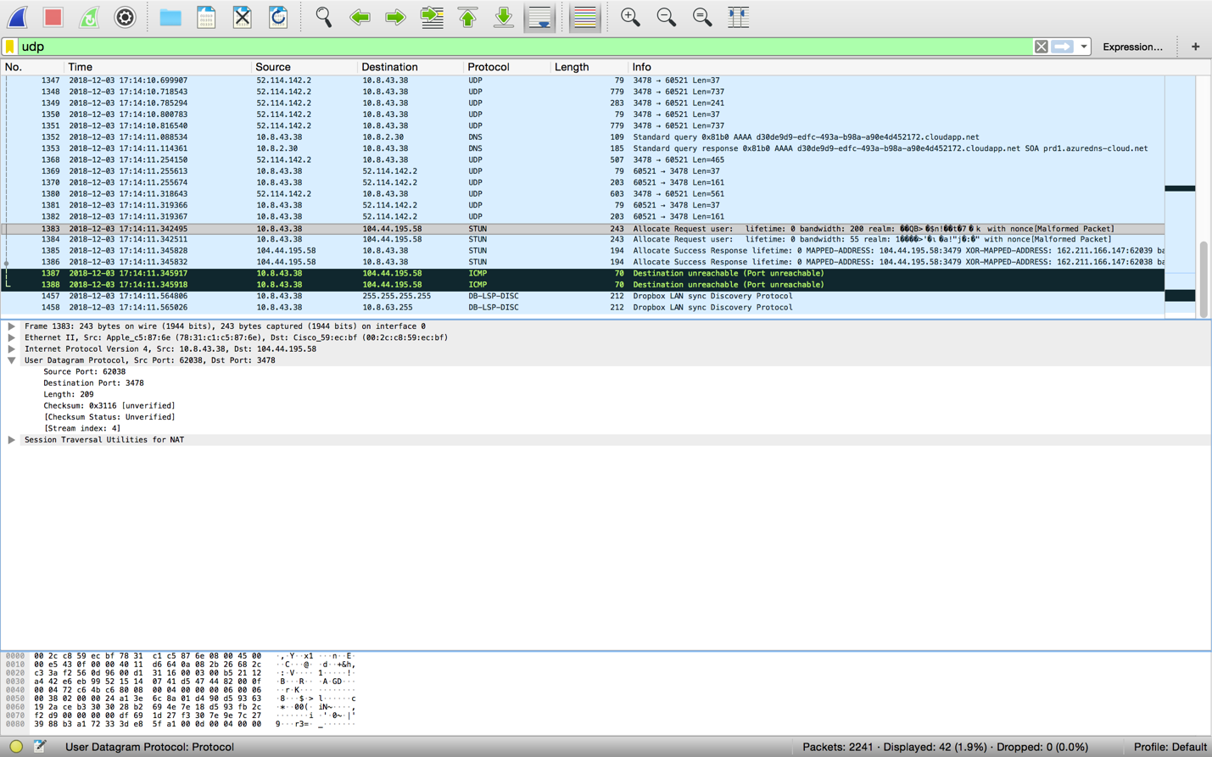

**Solution:**

Four (4) fields. Source port, Destination port, Length, and Checksum.

1. By consulting the displayed information in Wireshark’s packet content field for this packet, determine the length (in bytes) of each of the UDP header fields.

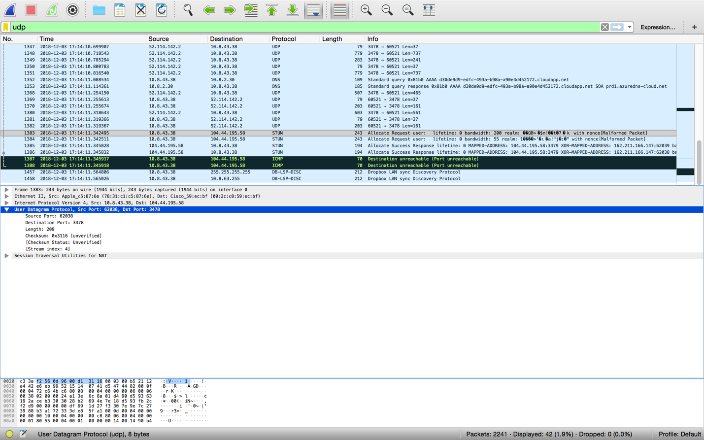

**Solution:**

The UDP header has a fixed length of 8 bytes and each of these four header fields is 2 bytes long.

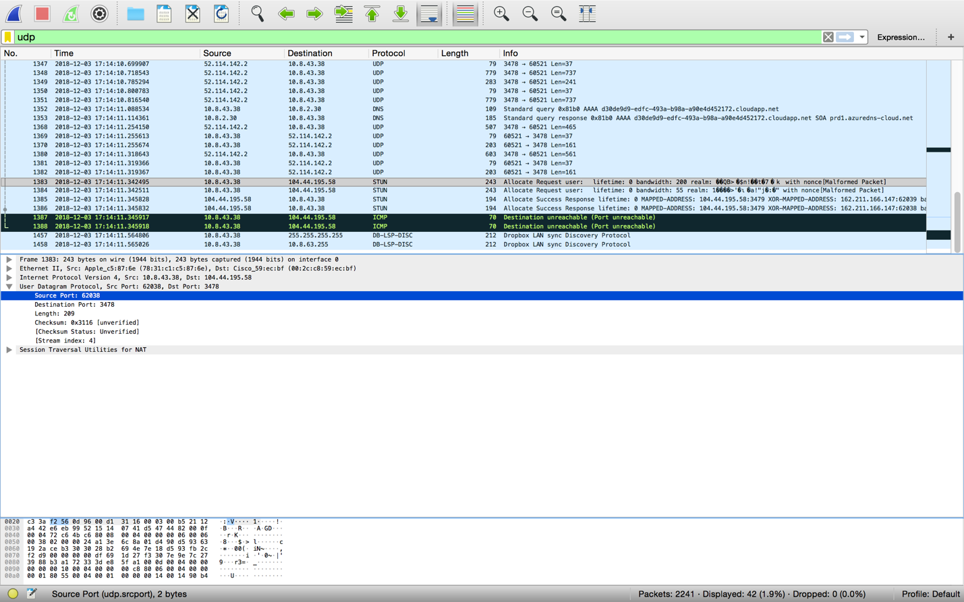

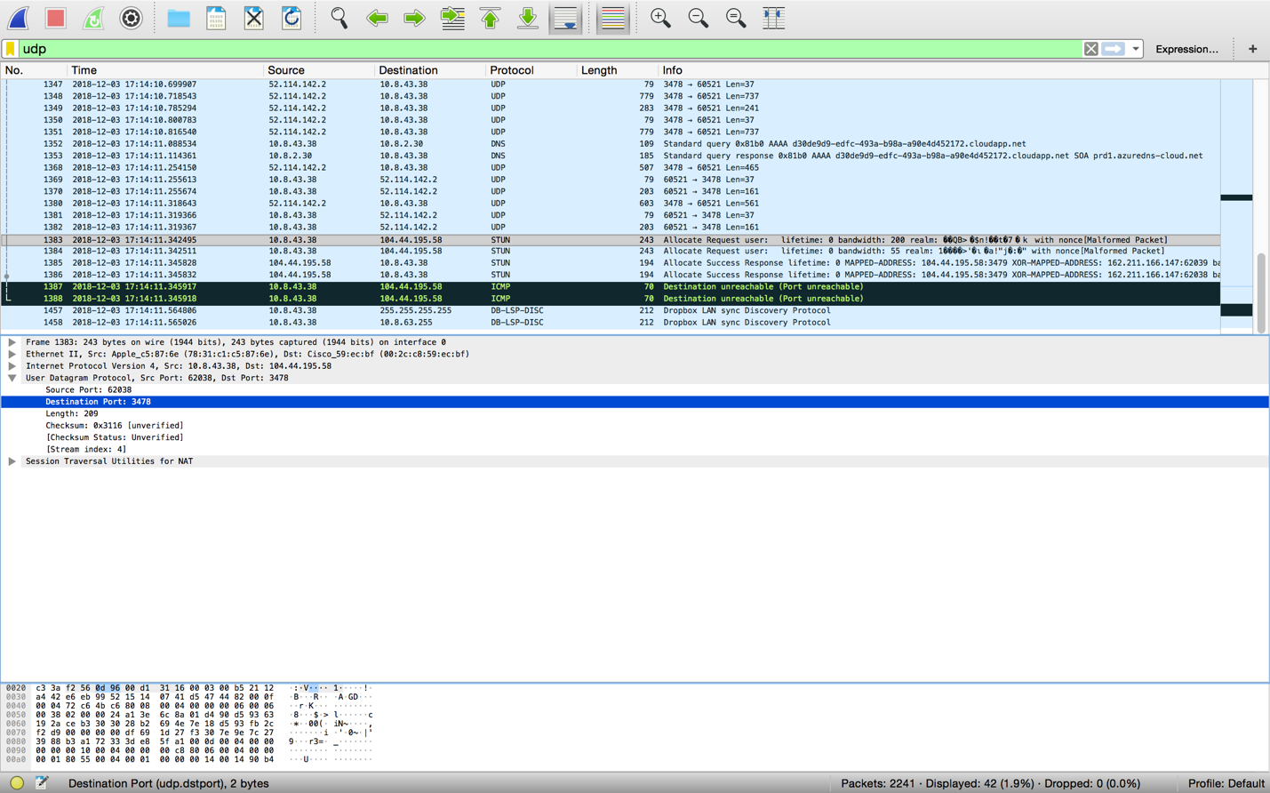

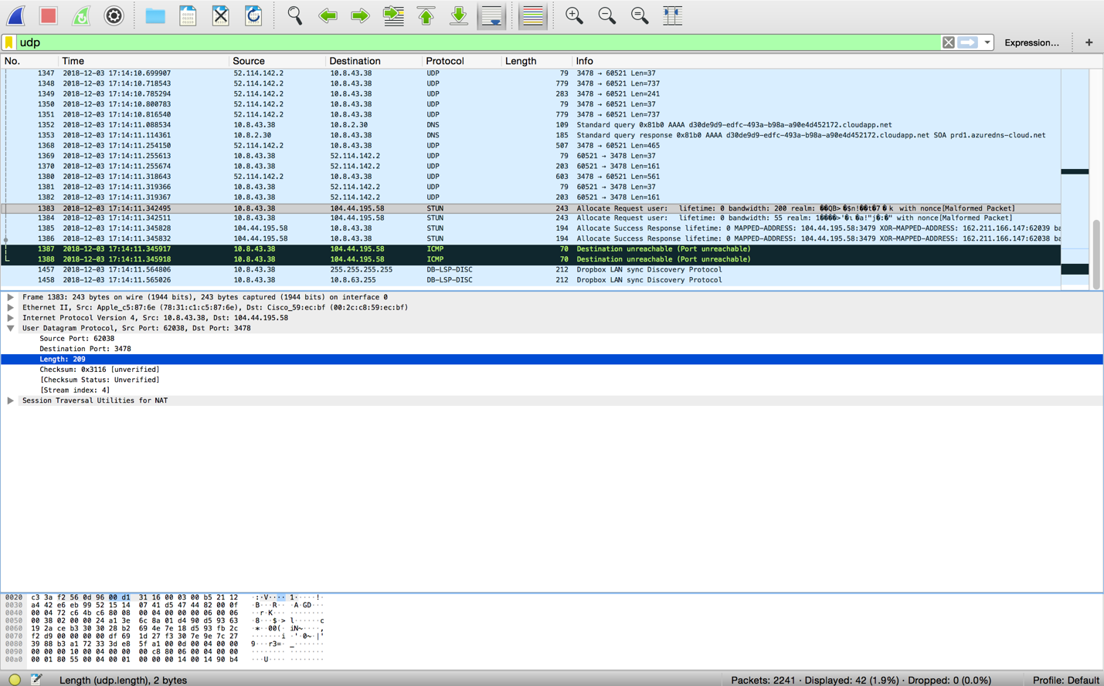

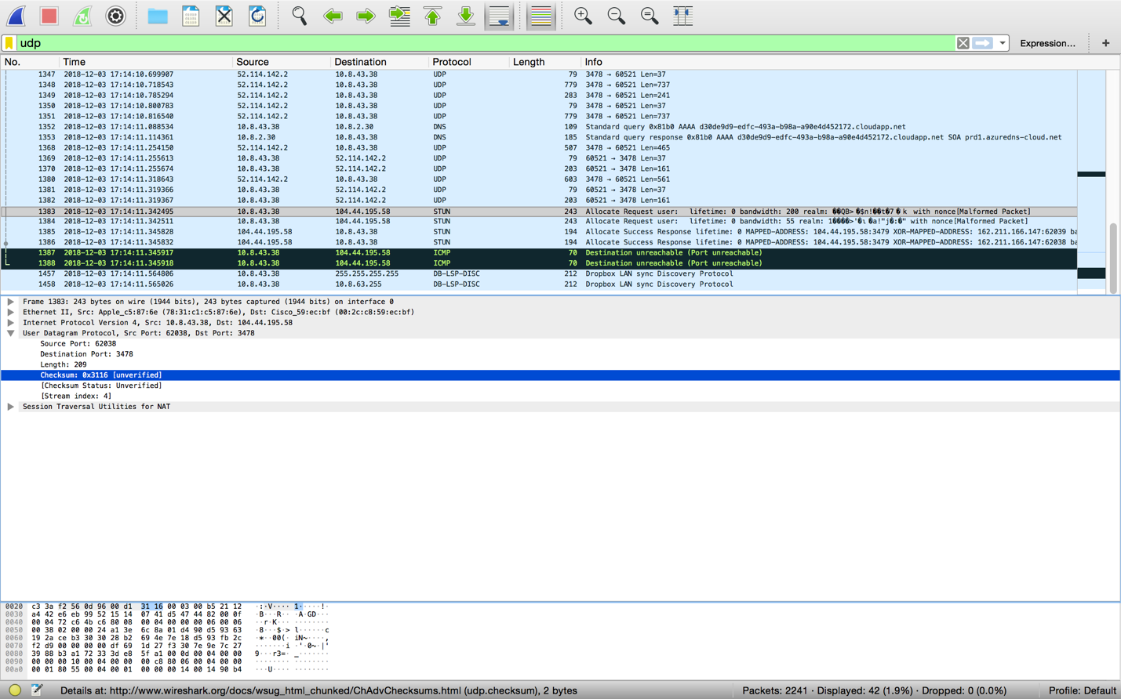

1. The value in the Length field is the length of what? Verify your claim with your captured UDP packet.

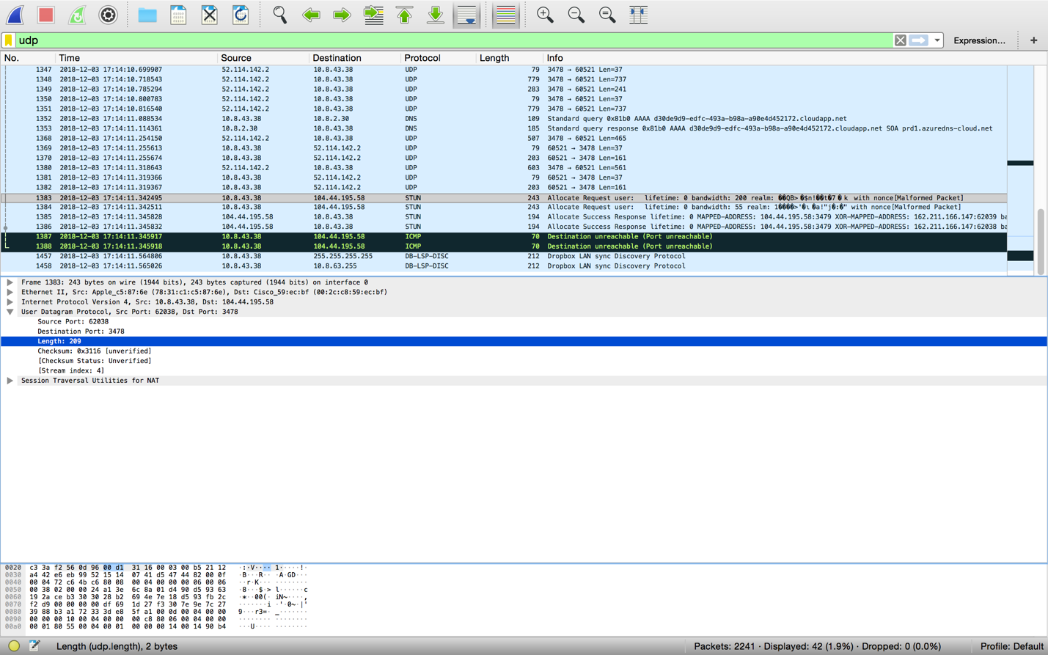

**Solution:**

The length field specifies the number if bytes in the UDP segment (header plus data). An explicit length value is needed since the size of the data field may differ from one UDP segment to the next. UDP payload for selected packet is 201 bytes. 209 bytes – 8 bytes = 201 bytes.

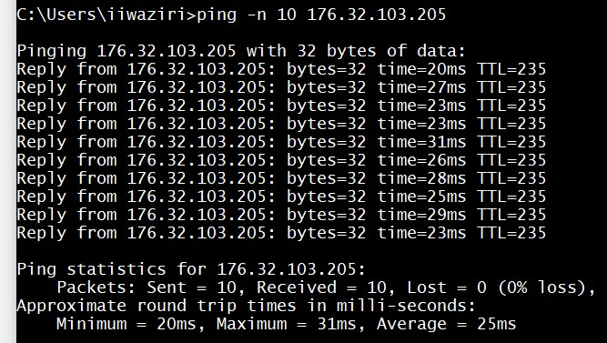

Use Figure 1 above to answer question 17 - 25

1. Explain what happened in Figure 1. (pay close attention to the command.)

**Solution**:

It’s asking the ping 10 responses from that ip address.

1. Which protocol is used to carry out the instruction in Figure 1.

**Solution:**

ICMP- Internet Control Message Protocol

1. Who owns the IP?

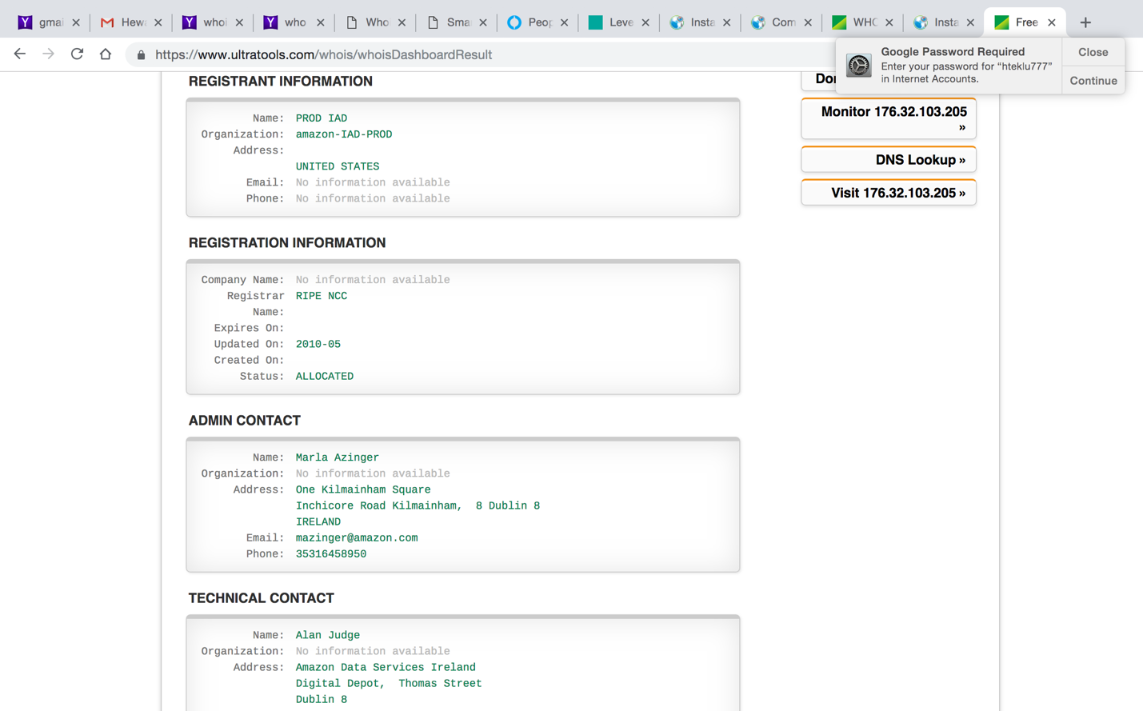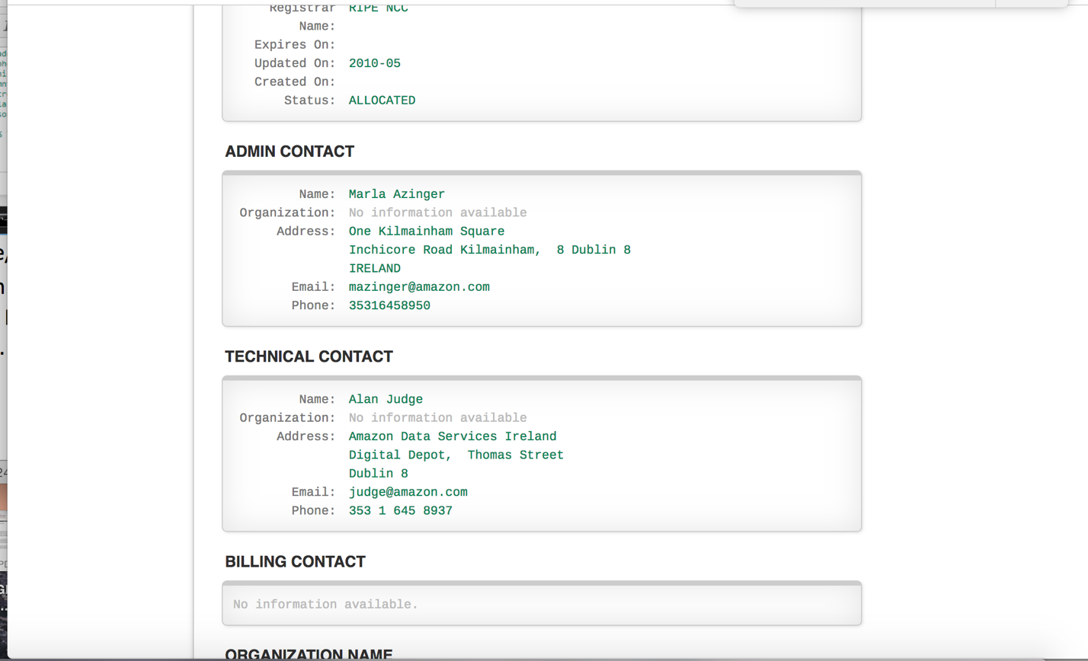

**Solution:**

Alan Judge/ Marla Azinger

1. In addition to a screenshot, in a tabular form, list all the hops between your computer’s IP and the IP address in Figure 1. The table should include the owner, and location of the IP address.

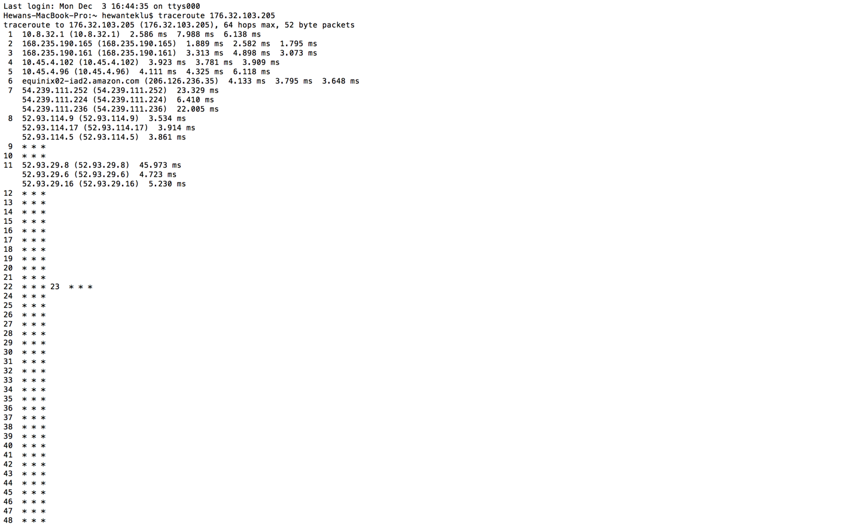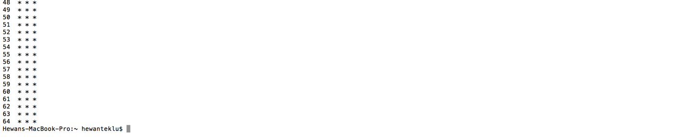

**Solution:**

|  |  |  |  |
| --- | --- | --- | --- |
| Hop Count | IP Address | Organization (IP Owner) | Location (US state)/Country |
| 1 | 10.8.32.1 | Internet Assigned Numbers Authority (IANA) | Los Angeles, CA/US |
| 2 | 168.235.190.165 | Allied Telecom Group, LLC | America/New_York |
| 3 | 168.235.190.161 | Allied Telecom Group, LLC | America/New_York |
| 4 | 10.45.4.102 | Internet Assigned Numbers Authority (IANA) | Los Angeles, CA/US |
| 5 | 10.45.4.96 | Internet Assigned Numbers Authority (IANA) | Los Angeles, CA/US |
| 6 | 206.126.236.35 | Equinix, Inc. (EQUINIX) | Redwood City, CA |
| 7 | 54.239.111.252 | Amazon Technologies Inc. (AT-88-Z) | Seattle, WA |
| 8 | 54.239.111.224 | Amazon Technologies Inc. (AT-88-Z) | Seattle, WA |
| 9 | 54.239.111.236 | Amazon Technologies Inc. (AT-88-Z) | Seattle, WA |
| 10 | 52.93.114.9 | Amazon Technologies Inc. (AT-88-Z) | Seattle, WA |
| 11 | 52.93.114.17 | Amazon Technologies Inc. (AT-88-Z) | Seattle, WA |
| 12 | 52.93.114.5 | Amazon Technologies Inc. (AT-88-Z) | Seattle, WA |
| 13 | 52.93.29.8 | Amazon Technologies Inc. (AT-88-Z) | Seattle, WA |
| 14 | 52.93.29.6 | Amazon Technologies Inc. (AT-88-Z) | Seattle, WA |
| 15 | 52.93.29.16 | Amazon Technologies Inc. (AT-88-Z) | Seattle, WA |

1. What version of TLS does the IP above use? Hint: Visit the website of the owners IP address, and capture the “Client Hello” packet.

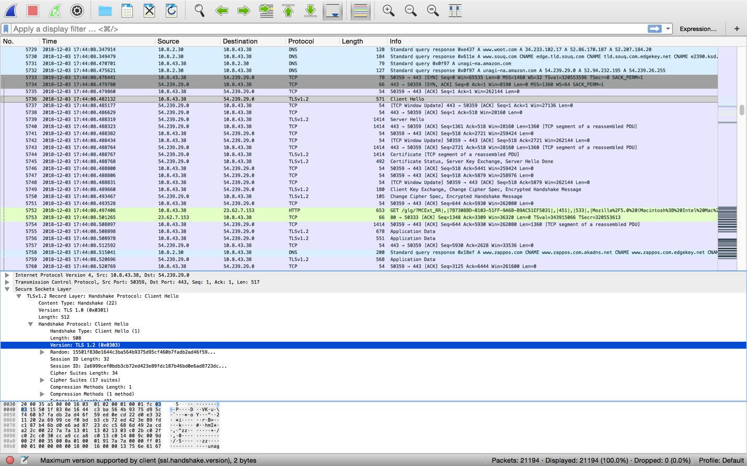

**Solution:**

Version: TLS 1.2

1. List all the algorithms listed in the Cipher Suite of the “Client Hello” packet in 21.

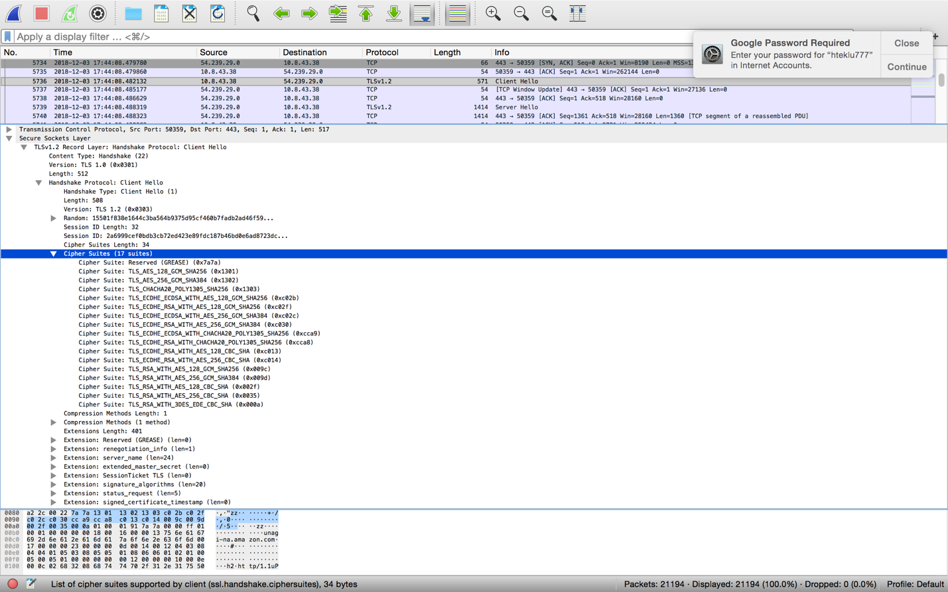

**Solution:**

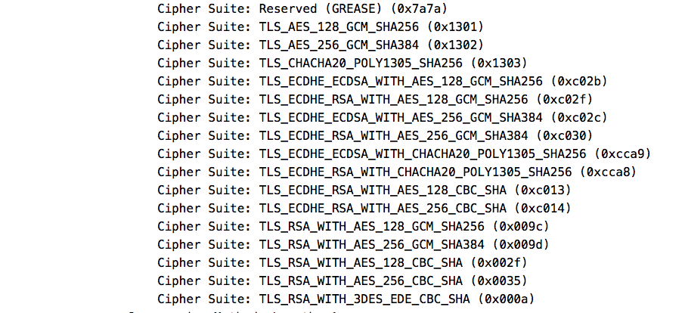

1. What TCP port number is used by the “Client Hello” packet, and why is it using that port number?

**Solution:**

**The Client Hello Packet uses Destination port number 443 because it is a standard TCP port that is used for websites that uses TLS/SSL. Amazon is an ecommerce site and it uses TLS as well as port 443.**

1. What are the source and destination MAC address?

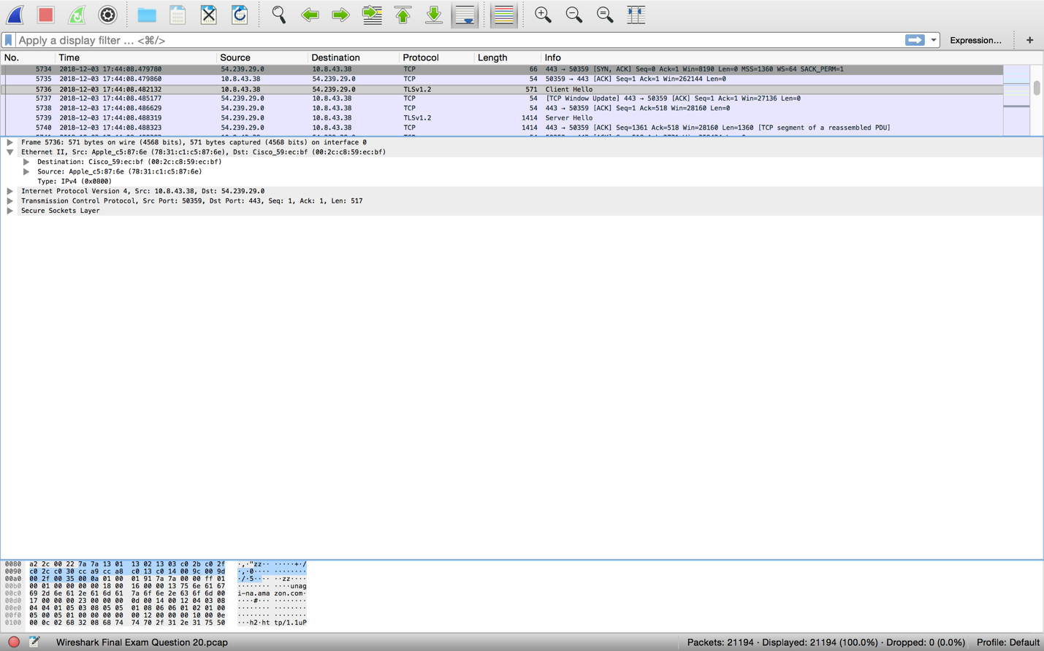

**Solution:**



1. Identify the company that manufactured the network cards with the MAC address identified in 8 above. (Hint: there are a lot of websites you can use to lookup MAC address, just like you would for an IP).

**Solution:**

Destination Mac Address

Company Name: Cisco System Inc.

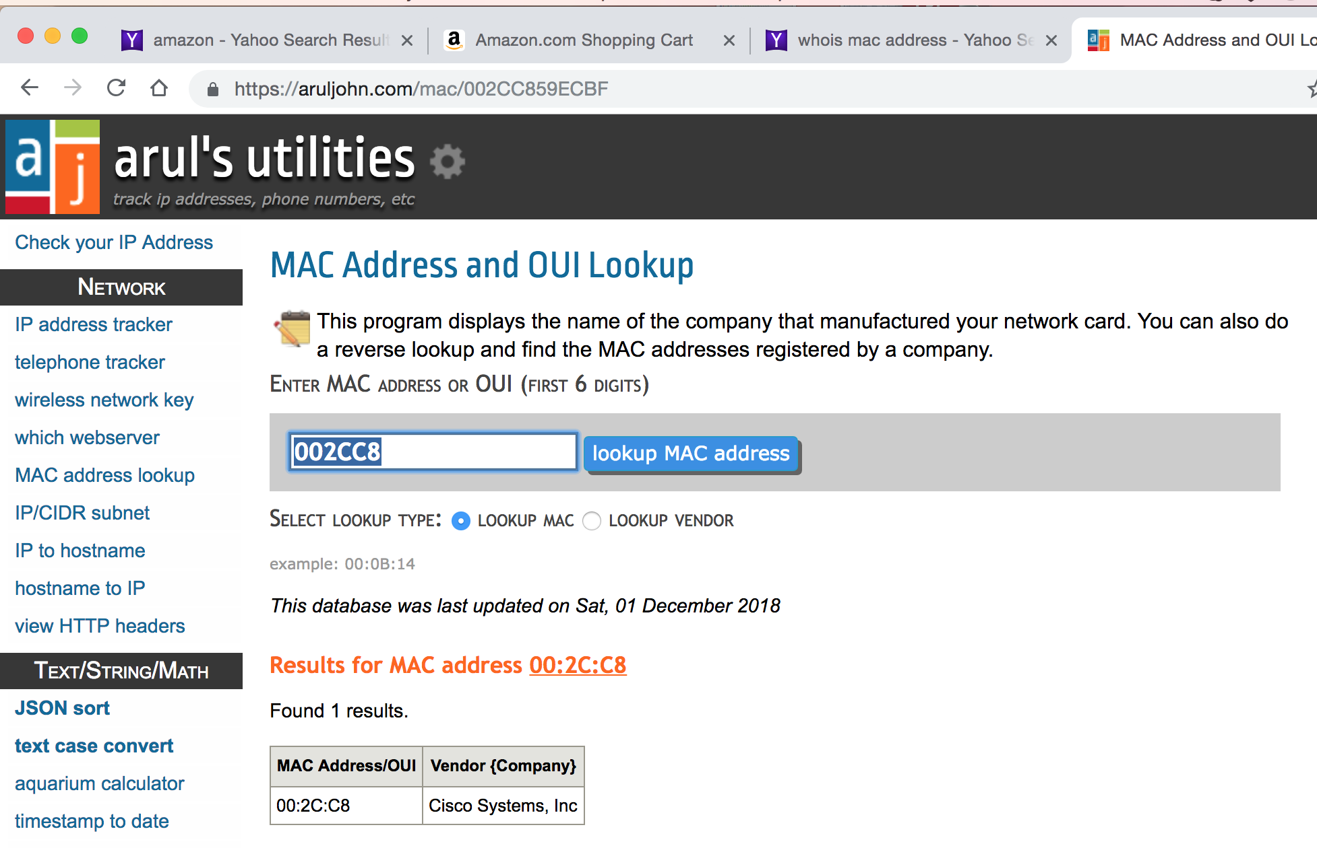

**Solution:**

Source Mac Address

Company Name: Apple Inc.

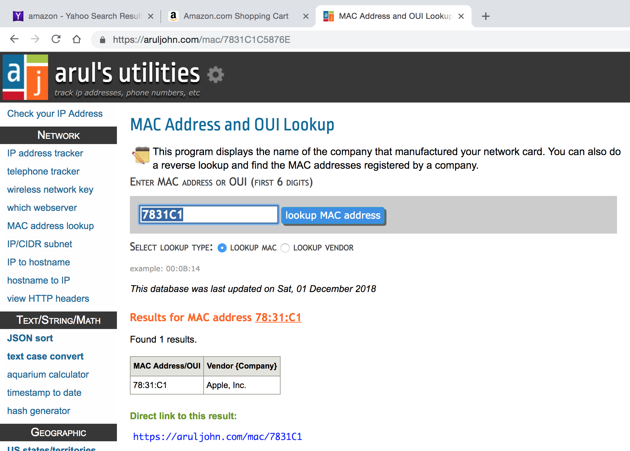

Extra Credit: (3 Marks)

Make a GitHub account and create a repository. Name the repo “wireshark_labs”. Add all the labs you did in this class (both Wireshark saved files and submitted reports). Add your GitHub username to the end of this lab or email it to me.